ORDERS AND ORDER_DETAILS SQL REPORT

1. Introduction
This report documents the SQL work completed for the Orders and Order_Details database. The work includes table creation, primary keys, foreign keys, NOT NULL constraints, CHECK constraints, table relationships, sample data insertion, JOIN operations, GROUP BY, COUNT, SUM, and AVG functions.

Tables and Constraints

Orders Table/Order_Details Table

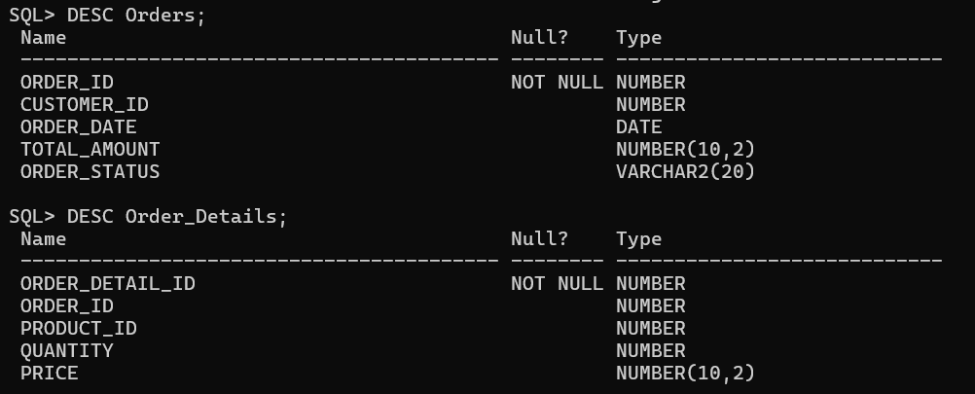

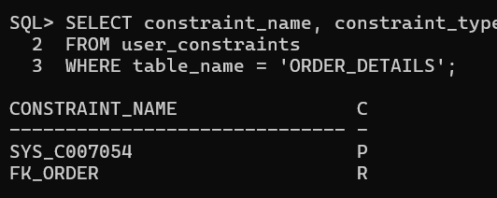
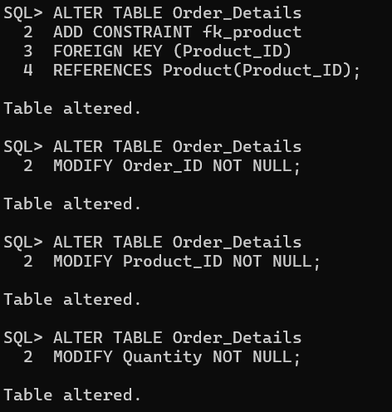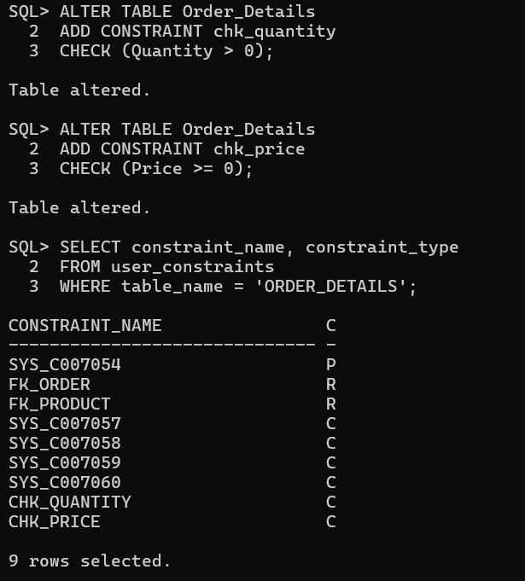

Sample Data

Orders

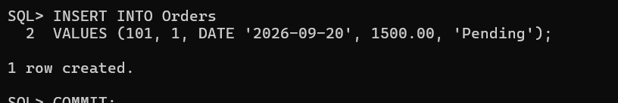

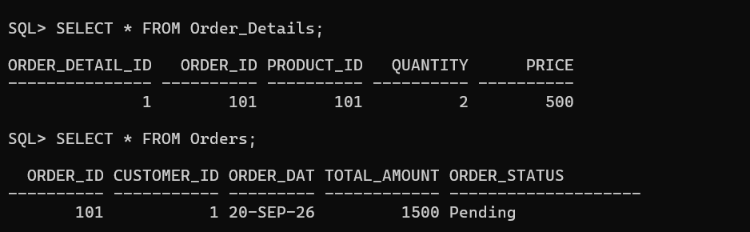
Report 1 – Customer Order History

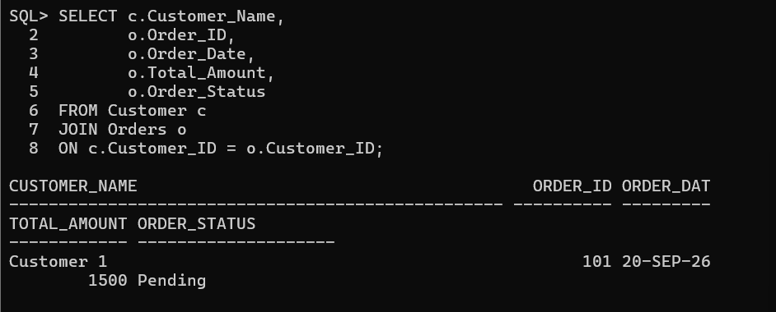

Product-wise Order Report
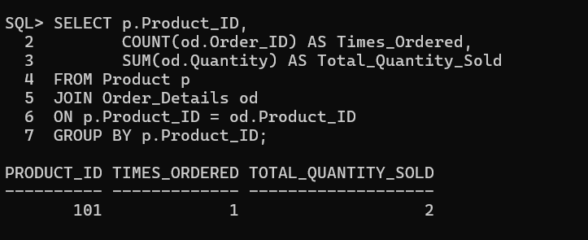
Report 3: Customer Purchase Analysis
Total Spending by Each Customer
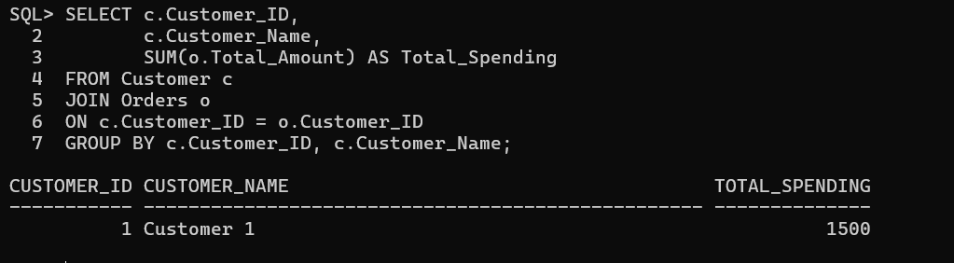
Average Order Value
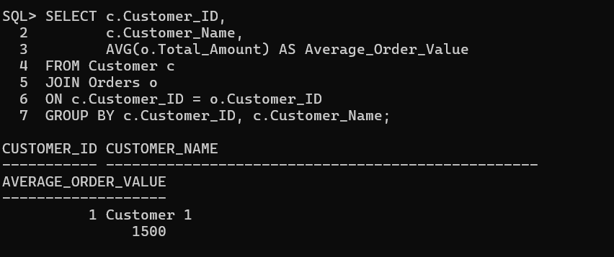
Customer with Maximum Orders
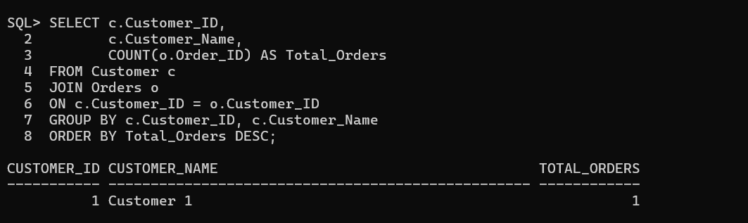

Conclusion
The SQL database was successfully implemented with Orders and Order_Details tables. Primary keys, foreign keys, NOT NULL constraints, and CHECK constraints were applied. SQL JOIN and aggregate functions such as COUNT, SUM, and AVG were used to generate customer order history, product-wise order reports, and customer purchase analysis.

